Project Title

Deciphering Silent Speech: A Multi-dimensional Neural Network Approach Using Conv3D, LSTM, and CTC for Lip-reading

Student Name

Zhenyi Li

Student Number

A00315981

MSc. Software Engineering 2024

TUS

##### Declaration

I hereby certify that the material, which is submitted in this thesis towards the award of MSc. Software Engineering, is entirely my own work and has not been submitted for any academic assessment other than part fulfilment of the above named award.

Future students may use the material contained in this thesis provided that the source is acknowledged in full.

Signed…………………………………………….

Date………………………………………………

##### Abstract

In this investigation, we examined the impact of image resolution on the performance of lip-reading models, with a focus on character error rate (CER) and word error rate (WER) as primary metrics. Two models were rigorously trained, one at a low resolution of 35x70 pixels and the other at a higher resolution of 70x140 pixels.The dataset we are using is one of the grid corpus datasets, which is a widely used dataset in the field of lip reading. The results were telling: the high-resolution model achieved a CER of 0.0008 and a WER of 0.0033, in contrast to the low-resolution model's CER of 0.3034 and WER of 0.3015. This indicates a significant performance leap with higher resolution inputs. However, the trade-off for precision was computational time, with the higher resolution training taking 4.319 hours, compared to 1.212 hours for the lower resolution. To translate these findings into practical insights, we have developed an online platform where users can gauge the model's accuracy in real-time scenarios. The direct comparison of CER and WER across resolutions highlights the delicate balance between model accuracy and computational efficiency in the field of automated lip-reading.

##### Acknowledgements

I extend my sincerest gratitude to my supervisor, Dr. Enda Farrell, for his invaluable guidance and insightful feedback throughout the duration of this project. His expertise and support have been cornerstones of my research journey.

I am also deeply thankful to Dr. Yuhang Ye for the enlightening lectures on Machine Learning and Deep Learning. His teachings were instrumental in helping me navigate through various challenges and his advice has been greatly appreciated.

Their combined contributions have not only shaped this research but have also greatly enriched my academic experience.

##### Table of Contents

Declaration ii

Abstract iii

Acknowledgements iv

Table of Contents v

List of Tables vii

List of Figures vii

Chapter 1: Introduction 1

1.1 Introduction 1

1.2 Research Aims and Objectives 1

1.3 Anticipated Contributions 2

Chapter 2: Background Research 3

2.1 Introduction 3

2.2 Dataset 11

2.3 Related Work 14

Chapter 3: System Design 19

3.1 Introduction 19

3.2 Requirements 21

3.3 Architecture 22

3.4 Training 24

3.5 Evaluation 25

3.6 Results 30

Chapter 4: Conclusions 33

4.1 Introduction 33

4.2 Reflection 33

4.3 Recommendations 33

4.4 Concerns 34

References 36

Glossary 40

List of Abbreviations 42

Appendix A: Appendix 44

A.1 A 44

##### List of Tables

Table 2.2.1: Information of datasets 14

Table 3.3.1: architecture of layers in model design 24

Table 3.3.2: parameters for models 24

Table 3.6.1: Comparative Analysis of Lip-Reading Models 31

##### List of Figures

Figure 2.1.1: The process of an automated lip-reading system 3

Figure 2.1.2: The structure of a convolutional layer. 5

Figure 2.1.3: The structure of LSTM 6

Figure 2.1.4: The structure of GRU 7

Figure 2.1.5: The structure of Transformer[27] 8

Figure 2.2.1: An overview of Lip Reading Datasets[35] 14

Figure 3.1.1: The architecture of the proposed lip-reading system. 20

Figure 3.5.1: CTC example for Alignment 29

Figure 3.6.1: CER and WER for different models 31

Figure 3.6.2: CTC Loss for different models 31

# Introduction

## Introduction

Lip reading is a complex visual task that involves deciphering speech from the movements of the lips, tongue, and face without auditory input. It is particularly critical for those with hearing impairments and has extensive applications in noisy environments where audio signals may be compromised. The advent of deep learning has significantly enhanced the prospects of automating this task, but achieving high accuracy depends on multiple factors including the resolution of the input data.

## Research Aims and Objectives

The core of our investigation revolves around assessing how input resolution affects the performance of advanced lip-reading models. Our chosen architectural framework combines three-dimensional convolutional neural networks (Conv3D), for their excellence in spatial feature extraction, with Long Short-Term Memory networks (LSTM), which are adept at understanding temporal sequences, and Connectionist Temporal Classification (CTC) for its effectiveness in training sequence prediction models. This holistic approach aims to harness the strengths of each component to achieve superior lip-reading accuracy.

We meticulously compare the character error rate (CER) and word error rate (WER) between models trained on datasets of varying resolutions: low (35x70 pixels) and high (70x140 pixels). These comparisons are not just statistical exercises but are aimed at understanding the intricate balance between computational demands and the fidelity of lip-reading accuracy. Such insights are pivotal for developing efficient and scalable lip-reading applications.

Furthermore, this study extends beyond theoretical analysis to practical application. The development of an online platform to test the models in real-world scenarios is a testament to our commitment to bridging the gap between academic research and practical utility. This platform will not only serve as a benchmark for our models but also as a resource for the community, facilitating further research and development in the field.

## Anticipated Contributions

This research is anticipated to contribute significantly to the field of automated lip reading by elucidating the nuanced impact of input resolution on model performance. By offering a detailed comparison of low and high-resolution datasets, we aim to provide guidelines for balancing computational efficiency with model precision. Additionally, the online platform we develop will serve as a valuable tool for researchers and practitioners alike, fostering further innovation and application of lip-reading technology in various domains.

# Background Research

## Introduction

Lip-reading which also called Vision Speech Recognition (VSR) is the process of understanding speech by observing a speaker’s lip movements, without hearing the sound. Lip-reading is a challenging task because of the variability in the lip movements of different speakers and the ambiguity in the lip movements of the same speaker. The variability in the lip movements of different speakers is due to the differences in the shape and size of the lips, the speed of speech, and the accent of the speaker. The ambiguity in the lip movements of the same speaker is due to the fact that the same lip movement can correspond to different sounds, and different lip movements can correspond to the same sound.[17] Lip-reading is an important task because it can be used to improve the performance of speech recognition systems in noisy environments[5][10], and to enable people with hearing impairments to communicate more effectively.[16]

Due to the development of deep neural networks and the availability of large datasets[25][26][23], lip-reading has evolved from recognition of single alphabets to recognition of complete words and recently to recognition of complete sentences,which is significantly improvement in the field of lip-reading.

Lip-reading can be typically followed by this framework:

1. **Front-end**: extract visual features from the input video.
2. **Back-end:** classify the visual features into words.

For an automated lip-reading system, the process are illustrated in Figure 2.1.1.



The process of an automated lip-reading system

### front-end: Feature extraction

The front-end of a lip-reading system plays a critical role in accurately interpreting and process visual speech information. It consists of two main components: mouth region detection and visual feature extraction,both of which are pivotal for the successful operation of the system.

#### Mouth Region Detection

The mouth region detection is to locate the mouth region in the input video, and normally it can be achieved by using face detection algorithms, like OpenCV, Dlib, MTCNN, mediapipe, etc. Once the mouth region is detected, it’s cropped, resized, and normalized to a fixed size, with standardized channel and RGB values. This normalization is crucial for ensuring consistency in the input data fed into the neural networks for visual feature extraction.

#### Visual Feature Extraction

The visual feature extraction is to extract visual features from the mouth region images. The visual features can be extracted by using neural networks, like CNN[11],RNN[31],LSTM[22][18],GRU[10],Transformer[1][18], etc. Most of the recent works use CNN to extract visual features. Because CNN can capture the spatial information of the input images, However, CNN can not capture the temporal information of the input images. To capture the temporal information of the input images, RNN,LSTM,GRU,Transformer can be used to support CNN.

#### CNN

CNN is a feedforward neural network that is designed to capture the spatial information of the input images. CNN is composed of multiple layers, including convolutional layers, pooling layers, and fully connected layers. The convolutional layers are used to extract features, the pooling layers are used to reduce the size of the features, and the fully connected layers are used to classify the features.

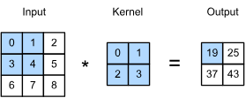

The structure of a convolutional layer.

In the convolutional layer, the input image is convolved with a set of filters to produce a set of feature maps. Each feature map is produced by convolving the input image with a filter and applying a non-linear activation function to the result. The feature maps are then passed through a kernel size to reduce the size of the feature maps. With multiple convolutional layers, the network can learn to extract features at different levels of abstraction.

#### RNN

Recurrent Neural Networks (RNNs) are pivotal in modeling sequence data, and the Long Short-Term Memory (LSTM) and Gated Recurrent Unit (GRU) architectures are two of the most popular RNN types used to capture temporal information effectively. Both are desgined to address the vanishing gradient problem commonly associated with standard RNNs, thereby enabling the learning of dependencies at different time scales.

LSTM units are an advanced type of RNN architecture which are designed to remember information for long periods of time. Each LSTM cell consists of components that work together to regulate the flow of information. These components are:

1. **Input Gate**: Determines how much of the new incoming information to store in the cell state.
2. **Forget Gate**: Decides the information that is no longer required by the model and thus can be thrown away from the cell state.
3. **Output Gate**: Controls the amount of information to be outputted from the current cell state to the next layer in the network.
4. **Cell State**: The internal memory of the LSTM which carries relevant information throughout the processing of the sequence.

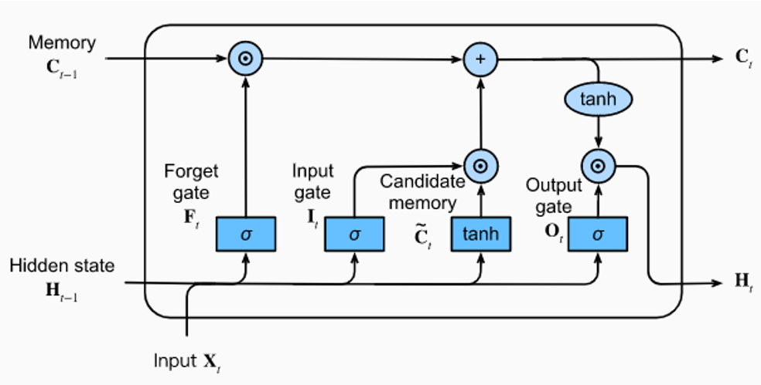

The structure of LSTM

GRU simplifies the LSTM architecture and merges the input and forget gates into a single “update gate.” It also merges the cell state and the hidden state,thereby reducing the complexity of the model. The GRU consists of the following components:

1. **Reset Gate**: Determines how much of the past information needs to be forgotten.
2. **Update Gate**: Decides how much of the new information needs to be stored in the cell state.
3. **Hidden State**: The new state is a blend of the old state and the new candidate state, controlled by the update gate.

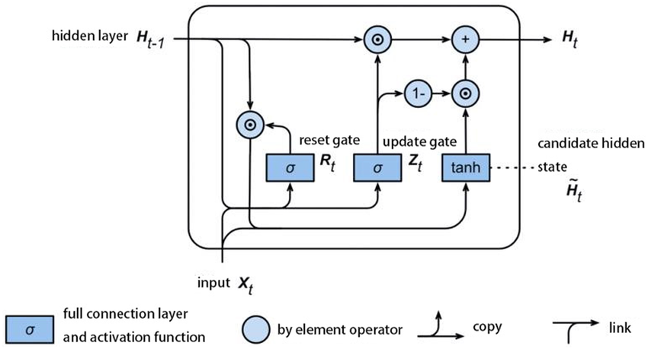

The structure of GRU

GRUs provide a more simplified and computationally efficient model compared to LSTMs while achieving similar performance, which makes them particularly useful when training data is limited or when computational efficiency is crucial.

#### Transformer

Transformer The Transformer model, introduced in the paper “Attention is All You Need”[27] by Vaswani et al.in 2017, represents a significant breakthrough in deep learning, particularly in the field of natural language processing(NLP). It deviates from previous sequence-to-sequence models that relied heavily on recurrent neural networks (RNNs) or convolutional(CNNs) layers, instead employing a novel architecture centered around the mechanism of self-attention.

Transformers provide a robust framework for addressing the complexities of lip-reading by effectively capturing both spatial and temporal relationships within visual data. Their ability to process sequences in parallel and their flexibility in focusing on different aspects of the input data make them highly effective for this application.

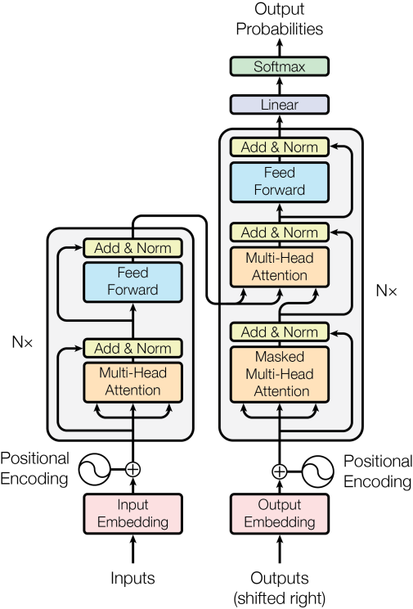

The structure of Transformer[27]

### Back-end: Classification Approaches

In the architecture of a lip-reading system, the back-end plays a crucial role akin to that of a decoder in traditional speech recognition systems. However, unlike typical audio-based systems, the back-end of a lip-reading system processes purely visual data inputs. This section provides an overview of how back-end classification and decoding operate within the context of lip-reading.

#### Role of the Back-end

The back-end’s primary function is to interpret and classify the visual features extracted from the mouth region by the front-end. These features are then mapped to their corresponding speech outputs, which could be in the form of phonemes[12][13][19], graphemes[28], words[4][5][7][8][29], or morphemes[30]. The specific processes involved include:

1. **Decoding Process**: This involves the conversion of classified data points into a sequence of speech outputs. Decoding in lip-reading utilizes several approaches:
   * **Phoneme-Level**: Breaking down speech into its smallest units of sound, providing a granular level of speech recognition.
   * **Grapheme-Level**: Similar to phoneme but focuses on the smallest units of written language that correspond to phonemes
   * **Word-Level**: Recognizing complete words, which is a more complex task due to the variability in lip movements and the ambiguity in visual speech cues.
   * **Morpheme-Level**: Deals with the smallest meaningful unites of language, which helps in understanding more complex linguistic structures.
2. **Classification Process**: This involves the mapping of visual features to their corresponding speech outputs. The key challenge here is to accurately identify the speech content based on the visual cues provided by the lip movements. Various classification approaches can be employed, including:
   * **Phoneme Classification**: Assigning phonetic labels to the visual features extracted from the mouth region.
   * **Word Classification**: Identifying complete words based on the visual cues provided by the lip movements.
   * **Sentence Classification**: Recognizing entire sentences, which requires a higher level of context and linguistic understanding.

#### Classification Models

The classification model is at the heart of the back-end, turning complex feature sets into intelligible outputs. Here are some of the typical approaches used:

Fully Connected Layers: After extracting and integrating features via the front-end, these are often passed through one or more dense layers that help in the classification of features into speech segments.

Softmax Activation: A softmax layer is commonly used as the final layer in the classification process. It converts the output of the neural networks into probability distributions, where each class’s probability signifies the likelihood of that class being the correct classification for the input data.

#### Techniques for Improving Classification

To refine the classification efficacy and adapt the back-end for practical applications, several strategies can be employed:

Temporal Pooling:Sometimes, pooling layers are used not just in the front-end for reducing spatial dimensions, but also in the back-end to aggregate temporal data effectively, providing a summarized representation of features over time. Sequence Modeling: Advanced sequence models like LSTMs or Transformers are particularly beneficial when sequences of visual data (like a sentence’s worth of lip movements) need to be classified. They can maintain context over longer sequences, improving overall accuracy. [22][14]

Hybrid Models: Incorporating both CNNs for spatial processing and RNNs or Transformers for sequence processing in the back-end allows the system to leverage the strengths of both architectural approaches—spatial precision and temporal context.[13]

Diffusion models: Merge audio and video inputs to enhance understanding. They employ advanced techniques like attention mechanisms and neural networks to capture both spatial and temporal cues. By leveraging unlabeled data through self-supervised learning, these models improve accuracy. [22][19][12][8]

#### Decoding and Mapping

Post-classification, the model outputs need to be decoded into human-readable text. This involves mapping the class labels (which could be phonemes, words, or other speech units) into actual spoken language:

* **CTC Decoding**: Connectionist Temporal Classification (CTC) is a popular decoding method that aligns the model’s predictions with the ground truth labels, allowing for variable-length outputs. It’s particularly useful when the model needs to predict sequences of varying lengths, such as words or sentences.[11][32][24]
* **Sequence-to-Sequence Models**: These models, often based on the encoder-decoder architecture, are used to map input sequences to output sequences. They are effective in lip-reading for translating visual features into spoken language outputs.[33][15]
* **Beam Search**: A search algorithm that explores multiple possible paths during decoding, allowing for more accurate predictions by considering various alternatives.
* **Language Models**: Incorporating language models can improve the lip-reading system’s accuracy by providing additional context and linguistic constraints during the decoding process.[34]
* **Post-Processing**: Techniques like language model rescoring or error correction can be applied after decoding to refine the final output and enhance the lip-reading system’s performance.[35]

## Datasets

Based on recording environments/settings, lip reading datasets can be categorized into two types: (1) controlled settings, and (2) lip-reading in the wild. Controlled settings involve videos recorded in stable environments where the position of the subjects and the speech content are precisely predefined. On the other hand, ‘lip-reading in the wild’ captures datasets from naturally occurring video content, such as lectures and debates, utilizing real-world variability and complexity. Each approach offers distinct benefits. The remainder of this section reviews major datasets collected under these settings, primarily in English, which is the predominant language in current collections, though several well-known datasets in other languages are also introduced (see Figure 2.2.1 and Table 2.2.1). It’s important to note that lip -reading datasets can also be classified based on the linguistic units they focus on, such as characters, digits, words, phrases, and sentences, as depicted in Figure 2.2.1. Subsequent sections will discuss data-related challenges, potential solutions, prevalent methods for generating synthetic samples, and the standard criteria for visual speech recognition (VSR) evaluation.

An straightforward solution is to record videos in a controlled environment, where a human subject is asked to repeat a set of predefined words or phrases in front of a camera. This method of dataset creation stems from the first application of automatic lip-reading: to control machines and computers with a specific set of instructions, such as voice commands. The limited size of vocabulary, clear pronunciations, and controlled recording settings are some important characteristics of such collections (referred to as controlled datasets). Moreover, due to the limited number of samples, the annotation process would be less laborious for human editors. In this section, we briefly review well-known datasets recorded in controlled settings, such as the GRID corpus, TCD-TIMIT, and MIRACL-VC1.

* GRID Corpus[3]: This dataset consists of 34 speakers (18 male and 16 female) each uttering 1000 sentences that cover a fixed grammar, which simplifies both the learning task and the annotation process. The consistent and simple structure of GRID makes it a standard choice for initial experiments in lip-reading research.
* TCD-TIMIT[6]: Unlike GRID, which uses simple phrases, TCD-TIMIT is derived from the phonetically-rich TIMIT audio corpus. It includes videos of 62 speakers reading phonetically balanced sentences, providing both audio and visual data which is ideal for multimodal learning experiments.
* MIRACL-VC1[9]: This dataset is specifically designed for developing voice control systems and features 15 speakers uttering a set of isolated words and commands. The controlled nature of MIRACL-VC1, with its clearly articulated phrases and limited lexical scope, makes it particularly useful for applications in command-driven computer interfaces. While datasets recorded in controlled environments offer distinct advantages for initial modeling and benchmarking, they exhibit several limitations that can restrict their application and utility in the field of Visual Speech Recognition (VSR). Characteristics such as a limited number of samples per class and a lack of diversity in subject demographics mean that while models trained on these datasets may perform well on development and test sets from the same collection, they often fail to generalize to videos recorded under real-world conditions. This failure is typically due to variations in illumination, speaker pose, and pronunciation distinctiveness that are not represented in controlled datasets. Furthermore, it is usually impractical to precisely annotate the boundaries of spoken units in videos during test time, which drastically reduces inference accuracy.

Controlled environment videos serve well as benchmarks for evaluating VSR pipelines, to pre-train models, and to accelerate training convergence. However, the need to develop proper lip-reading datasets from videos recorded in uncontrolled, or ‘in the wild’, scenarios remains critical. Therefore, a robust dataset preparation technique must be designed to automate the annotation process and increase dataset utility.

The automation of video annotation has significantly reduced the workload on human editors and has led to the development of several datasets that not only improve the accuracy of trained models but also enhance their robustness and reliability. In what follows, we review some of the well-known English datasets in the wild:

* **LRW (Lip Reading in the Wild)[2]**: This dataset features clips from a variety of BBC programs, capturing over 500,000 instances of 1,000 words spoken under naturalistic settings. It challenges models with a range of accents, lighting conditions, and non-frontal speaker orientations.
* **LRS2 and LRS3-TED[26]**: Extended from LRW, these datasets include longer phrases and full sentences from BBC shows and TED Talks, respectively. They provide models exposure to more complex linguistic structures and diverse speaking styles, making them highly suitable for advanced lip-reading tasks.
* **AVSpeech[36]**: Comprising millions of aligned audio-visual segments from YouTube, this dataset is particularly valuable for training models to perform in highly varied acoustic and visual environments.

| **Dataset Name** | **Description** | **Language** | **Number of Speakers** | **Number of Utterances/Clips** |
| --- | --- | --- | --- | --- |
| LRW (Lip Reading in the Wild) | Consists of short clips from BBC programs, focused on isolated words | English | Various | 500,000+ clips |
| GRID | A simple, controlled dataset with high-quality video; speakers utter simple phrases | English | 34 | 34,000 clips |
| LRS2 (Lip Reading Sentences 2) | Extended dataset from BBC programs, includes a variety of speaking styles and lighting conditions | English | Various | ~100,000 clips |
| LRS3-TED | Extracted from TED and TEDx talks, it features open-domain content with diverse accents | Multilingual | Various | ~150,000 clips |
| TCD-TIMIT | Audio-visual dataset derived from the TIMIT corpus of read speech | English | 62 | ~7,000 clips |
| AVLetters | Focuses on single letters spoken by multiple speakers; used for simpler lip-reading tasks | English | 10 | 780 clips |
| AVSpeech | Composed of clips from YouTube, linking to untrimmed videos containing clean speech segments | Multilingual | Various | Millions of segments |
| MIRACL-VC1 | Features single words and commands for voice control use-cases, in a controlled environment | English | 15 | 1,650 clips |

Information of datasets

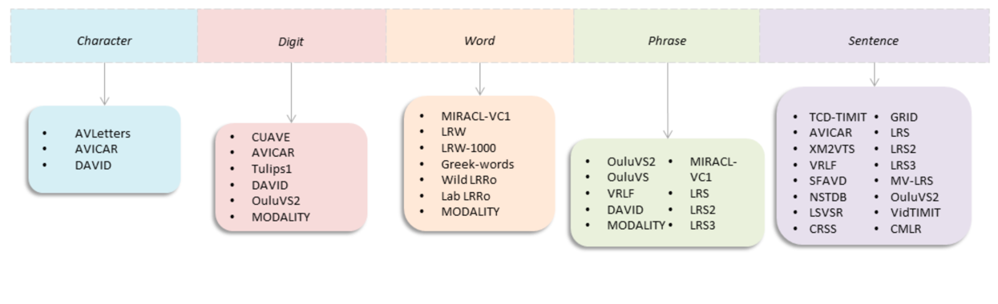

An overview of Lip Reading Datasets[35]

## Related Work

Assael et al. introduce “LipNet,”[11] an innovative deep learning model for sentence-level lipreading that maps video frames of a speaker’s mouth directly to text without needing manual alignment or segmentation. Utilizing spatiotemporal convolutions, recurrent neural networks, and connectionist temporal classification (CTC) loss in an end-to-end training approach, LipNet is evaluated using the GRID corpus. achieved a remarkable 95.2% accuracy in sentence-level word prediction, LipNet significantly outperforms experienced human lipreaders and prior models, demonstrating effective generalization across unseen speakers and sensitivity to key phonological features. This breakthrough suggests that with more extensive datasets, the model could be further improved and potentially applied to more complex audio-visual speech recognition tasks, representing a substantial advancement in assistive technologies for the hearing impaired and robust speech recognition systems in noisy environments

Ma et al. explore the augmentation of training datasets for Audio-Visual Speech Recognition (AVSR)[19] through the use of automatically-generated transcripts of unlabeled datasets. This innovative approach leverages the capabilities of existing pre-trained Automatic Speech Recognition (ASR) models to transcribe large-scale datasets like AVSpeech and VoxCeleb2, addressing the challenge of expensive and time-consuming manual labeling. The authors demonstrate that incorporating these automatically transcribed datasets into the training process, alongside traditional datasets such as LRS2 and LRS3, significantly enhances model performance, achieving state-of-the-art results on LRS2 and LRS3 with a notable Word Error Rate (WER) reduction. This study not only sets new benchmarks in AVSR performance but also illustrates the potential of utilizing automatically generated labels to expand training datasets, thus paving the way for more robust and accurate AVSR systems capable of functioning effectively in real-world noise conditions.

In “Deep Audio-Visual Speech Recognition,” Afouras et al.[5] explore the enhancement of speech recognition through the integration of audio and visual data using transformer-based models, tested on the LRS2-BBC dataset. The study demonstrates how visual information can significantly improve recognition accuracy in noisy environments by employing models with dual attention mechanisms that process both modalities. Particularly, the seq2seq model excels in environments with clean audio, while combined with the CTC model, it adeptly handles asynchronous data scenarios. This research advances audio-visual speech recognition, offering robust solutions for real-world applications, such as interactive systems and aids for the hearing impaired, underscoring the potential of multimodal approaches in overcoming environmental noise challenges.

Ma, Petridis, and Pantic[19] present a pioneering study that integrates a hybrid CTC/Attention model using ResNet-18 and Conformer architectures for audio-visual speech recognition (AVSR). This model uniquely processes raw pixels and audio waveforms directly, eschewing pre-computed features common in earlier models. Evaluated on the largest publicly available sentence-level speech datasets, LRS2 and LRS3, the approach significantly outperforms previous models in audio-only, visual-only, and audio-visual configurations, demonstrating robustness across diverse noise conditions. By replacing recurrent networks with Conformers and employing a transformer-based language model, the study not only enhances performance but also sets new benchmarks in the field, showcasing the effectiveness of end-to-end training in AVSR.

Battenberg et al.[13] perform a comprehensive empirical comparison among three prominent speech recognition models: CTC, RNN-Transducer, and attention-based Seq2Seq. These models are evaluated for their ability to handle end-to-end learning without reliance on language models, demonstrating that Seq2Seq and RNN-Transducer models significantly outperform traditional CTC approaches on the Hub5’00 benchmark. The study finds that the RNN-Transducer not only simplifies the decoding process but also enhances model performance through its unique handling of alignment and output dependencies, without the conditional independence limitations seen in CTC. This work highlights the efficacy of RNN-Transducers in reducing the complexity of speech recognition systems while maintaining high accuracy, thereby setting the stage for future innovations in speech processing technologies.

Shillingford et al.[12] from DeepMind and Google tackle the challenge of open-vocabulary visual speech recognition by creating the largest dataset of its kind, featuring 3,886 hours of video which maps video clips of faces to sequences of phonemes and words. Their system, which includes a novel lip-reading model called Vision to Phoneme (V2P), leverages spatiotemporal convolutions and a deep neural network to reduce the word error rate (WER) to 40.9%, a significant improvement over professional lipreaders and previous methods such as LipNet and Watch, Attend, and Spell (WAS), which achieve WERs of 89.8% and 76.8%, respectively. This work not only advances the state-of-the-art in visual speech recognition but also demonstrates the potential of using such technologies to aid individuals with speech impairments, contributing a substantial dataset and a scalable model framework for future research.

Yeng et al.[23] present a comprehensive analysis of various training strategies to optimize lip reading models without overhauling the underlying architecture. Utilizing the LRW and LRW-1000 datasets, they enhance a baseline lip reading model through incremental refinements in data processing, training protocols, and module choices, improving performance dramatically—from 83.7% to 88.4% and from 38.2% to 55.7% accuracy on these datasets, respectively. Key innovations include the integration of easy-to-implement enhancements such as MixUp augmentation, label smoothing, and learning rate scheduling adjustments. Their results not only surpass current state-of-the-art outcomes but also demonstrate the substantial impact of refined training techniques on the efficacy of deep learning models in visual speech recognition. This study underscores the potential of ‘low-cost’ optimizations to significantly advance model performance, offering a pragmatic roadmap for future research in lip reading and related fields.

Kim, Hong, and Ro[21] from KAIST propose an innovative multi-task learning framework that enhances lip-to-speech synthesis by incorporating both feature-level and output-level content supervision. This methodology addresses the challenge of synthesizing intelligible speech in uncontrolled environments by leveraging multimodal supervision, which combines textual and acoustic cues. By integrating Connectionist Temporal Classification (CTC) for text prediction and a novel acoustic feature reconstruction strategy, their model achieves high-quality speech synthesis across diverse conditions found in the LRS2, LRS3, and LRW datasets. The results show significant improvements in Word Error Rates (WERs), outperforming previous state-of-the-art methods and demonstrating the model’s ability to handle sentence complexity and speaker variability effectively. This approach not only advances the capabilities of lip-to-speech systems but also suggests a scalable framework for developing more robust speech technologies in noisy and dynamic settings.

Chung, Senior, Vinyals, and Zisserman introduce the Watch, Listen, Attend and Spell (WLAS) network[4], a pioneering approach to unconstrained lip reading in natural language sentences, using a novel dual attention mechanism that decodes visual information from video input into character-level transcriptions. Leveraging the newly developed large-scale Lip Reading Sentences (LRS) dataset, composed of over 100,000 sentences from diverse BBC television broadcasts, their model significantly surpasses the performance of all previous works on standard lip reading benchmarks. This study not only demonstrates the capability of WLAS to outperform professional human lip readers in transcribing spoken content from video but also highlights the utility of integrating audio-visual data to improve speech recognition systems, particularly in noisy environments. The results advocate for the expansion of visual speech recognition technologies, potentially benefiting silent film analysis, multi-speaker communication, and general speech recognition enhancements.

Hong et al. address the challenge of simultaneous audio and visual input corruption in Audio-Visual Speech Recognition ( AVSR)[37]. The paper introduces a novel framework, the Audio-Visual Reliability Scoring module (AV-RelScore), which dynamically assesses the reliability of each modality to optimize speech recognition accuracy under multimodal corruption. This method is particularly effective in environments where both audio and visual signals may be degraded, such as noisy or visually obstructed settings encountered in real-world applications. Extensive experiments on the LRS2 and LRS3 datasets demonstrate that the AV-RelScore framework not only outperforms traditional unimodal and multimodal approaches in terms of robustness but also provides a significant reduction in word error rate (WER), thereby advancing the state-of-the-art in robust AVSR technologies.

The ensemble of reviewed studies underscores substantial advancements in audio-visual speech recognition (AVSR) and lip-reading through the integration of deep learning technologies. Key insights include the efficacy of end-to-end models like LipNet, which bypass manual segmentation to notably exceed traditional accuracy benchmarks. Utilizing automatically generated transcripts to train on large-scale, unlabeled datasets has been shown to enhance model performance significantly. Innovations such as Conformers and transformer-based models that process raw inputs directly have set new performance standards, especially in noisy environments. These studies affirm the crucial role of multimodal data integration for maintaining accuracy amidst poor audio quality and highlight methods that dynamically assess the reliability of multimodal inputs, bolstering robustness in varied real-world conditions. Moreover, strategic training optimizations and data augmentation methods are instrumental in advancing lip-reading model capabilities. Collectively, these technological strides are paving the way for more inclusive and effective communication systems, tailored to real-world applications.

# System Design

## Introduction

In this paper, we investigate the influence of input resolution on the performance of a lip-reading model that integrates three-dimensional convolutional neural networks (Conv3D), Long Short-Term Memory networks (LSTM), and Connectionist Temporal Classification (CTC) for training. This combination leverages spatial feature extraction through Conv3D, temporal dynamics captured by LSTM, and an end-to-end training approach offered by CTC, which is well-suited for sequence prediction problems such as lip-reading. Our study compares the character error rate (CER) and word error rate (WER) of two models: one trained on low-resolution (35x70 pixels) and the other on high-resolution (70x140 pixels) datasets. These metrics gauge the models’ abilities to accurately recognize and reproduce characters and words from visual information alone. By presenting a side-by-side analysis of models trained with varying input resolutions, we aim to illuminate the trade-offs between computational efficiency and the precision of lip-reading models. Furthermore, the paper discusses the implementation of an online platform to assess the practical capabilities of the trained models in real-world scenarios.

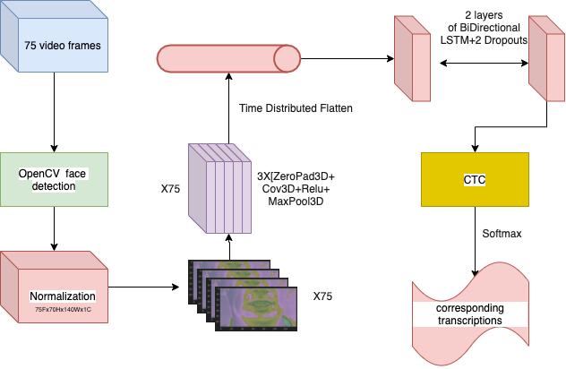

The architecture of the proposed lip-reading system.

The system starts by processing 75 frames of video data, where each frame is processed to detect the speaker’s face using OpenCV’s face detection capabilities. Once the region of interest is isolated, it undergoes a normalization process to standardize the input for consistent model training.

At the core of the model are three layers of 3D convolutions (Conv3D), each followed by a Rectified Linear Unit (ReLU) activation and 3D max pooling. These layers are designed to capture the spatial and temporal patterns of mouth movements across the video sequence.

Following the convolutional base, the output is then flattened and distributed over time to transform the data into a format suitable for sequential processing. This is crucial for preparing the high-dimensional convolutional output for the recurrent layers that follow.

The temporal dynamics of speech are modeled using a stack of two bidirectional Long Short-Term Memory (LSTM) layers, with dropout layers interspersed to prevent overfitting. This bidirectional approach captures dependencies in both directions of the temporal sequence, which is essential for understanding the context of visual speech.

Finally, a Connectionist Temporal Classification (CTC) layer aligns the input sequences with their corresponding transcriptions without requiring pre-segmentation, a method particularly well-suited for tasks with variable-length inputs and outputs. The output of the CTC layer is then passed through a softmax activation function to generate a probability distribution over the possible transcriptions for each sequence.

This system design, which integrates face detection, convolutional neural networks, LSTM layers, and CTC within an end-to-end trainable model, is tailored to maximize performance for sentence-level lip-reading tasks. By utilizing the GRID dataset, known for its clear structure and limited vocabulary, the model is expected to deliver high-accuracy transcriptions even on systems without specialized hardware, making it a versatile solution for real-world speech recognition challenges.

## Requirements

Our lip-reading system is developed in Python and utilizes TensorFlow and PyTorch frameworks for deep learning tasks. Additionally, we employ OpenCV and MediaPipe for video processing and facial feature extraction. The system is designed to be flexible,accommodating both TensorFlow and PyTorch implementations to cater to different user preferences and requirements.

### TensorFlow Implementation

For the TensorFlow implementation, we recommend the jupyter notebook environment for interactive development and testing of the lip-reading model. Because in jupyter notebook, you can easily visualize the intermediate outputs and debug the code. The following libraries are required for the TensorFlow implementation:

Jupyter notebook: An interactive development environment for running Python code in a notebook format.

TensorFlow: An open-source deep learning framework developed by Google for building and training neural networks.

OpenCV: A computer vision library that provides tools for image and video processing.

### PyTorch Implementation

For the PyTorch implementation, we recommend using the PyCharm IDE for a more structured development environment. In PyTorch, you can easily look at the whole codebase and navigate through the codebase,which is beneficial for large projects, and it provides a more comprehensive debugging experience. The following libraries are required for the PyTorch implementation:

PyCharm: An integrated development environment for Python that provides code navigation, debugging, and code completion features.

PyTorch: An open-source deep learning framework developed by Facebook for building and training neural networks.

MediaPipe: A library that provides tools for face detection, facial landmark detection, and pose estimation.

ctcdecode: A library that provides connectionist temporal classification (CTC) decoding for PyTorch models

### Hardware Requirements

We recommend using a machine with a GPU memory of at least 8GB for training the lip-reading model. The GPU should be capable of running deep learning tasks efficiently, and we recommend using NVIDIA GPUs for optimal performance. For inference tasks, a CPU with at least 16GB of RAM is sufficient to run the lip-reading model.We also recommend using ubuntu 20.04 LTS as the operating system for the development of the lip-reading system.

## Architecture

In our study, we adopted a Conv3D-LSTM-CTC architecture for our lip-reading system. The models were evaluated at two different resolutions: the baseline model at 70x140 pixels and a reduced resolution model at 35x70 pixels. The system processes a sequence of 75 video frames, each transformed to a dimensionality of T x H x W x C, where T represents the number of frames, H is the frame height, W is the frame width, and C denotes the number of channels. Specifically, the dimensions are (75, 70, 140, 1) for the baseline model and (75, 35, 70, 1) for the low-resolution model. The batch size is omitted for clarity in the information flow as described.

Once the video data enters the system, it encounters a succession of 3D convolutional layers designed to extract comprehensive spatial and temporal features from the imagery of the mouth region. Following this feature extraction, the data is flattened and then reshaped, a necessary preprocessing step for the LSTM layers. These LSTM layers are configured to be bidirectional, thereby capturing the nuanced temporal dependencies present in both forward and reverse directions of the speech sequence.

The penultimate stage of the process involves the output from the LSTM layers being channeled into a Connectionist Temporal Classification (CTC) layer. This CTC layer plays a pivotal role in aligning the variably timed input sequences with the corresponding textual labels, thereby enabling the model to generate accurate transcriptions of the spoken words captured in the video frames.

| **Layer Type** | **Layer Name** | **Input Shape (75x70x140)** | **Output Shape (75x70x140)** | **Input Shape (75x35x70)** | **Output Shape (75x35x70)** |
| --- | --- | --- | --- | --- | --- |
| **InputLayer** | **conv3d_12_input** | **(75, 70, 140, 1)** | **(75, 70, 140, 1)** | **(75, 35, 70, 1)** | **(75, 35, 70, 1)** |
| **Conv3D** | **conv3d_12** | **(75, 70, 140, 1)** | **(75, 70, 140, 128)** | **(75, 35, 70, 1)** | **(75, 35, 70, 128)** |
| **Activation** | **activation_12** | **(75, 70, 140, 128)** | **(75, 70, 140, 128)** | **(75, 35, 70, 128)** | **(75, 35, 70, 128)** |
| **MaxPooling3D** | **max_pooling3d_12** | **(75, 70, 140, 128)** | **(75, 35, 70, 128)** | **(75, 35, 70, 128)** | **(75, 17, 35, 128)** |
| **Conv3D** | **conv3d_13** | **(75, 35, 70, 128)** | **(75, 35, 70, 256)** | **(75, 17, 35, 128)** | **(75, 17, 35, 256)** |
| **Activation** | **activation_13** | **(75, 35, 70, 256)** | **(75, 35, 70, 256)** | **(75, 17, 35, 256)** | **(75, 17, 35, 256)** |
| **MaxPooling3D** | **max_pooling3d_13** | **(75, 35, 70, 256)** | **(75, 17, 35, 256)** | **(75, 17, 35, 256)** | **(75, 8, 17, 256)** |
| **Conv3D** | **conv3d_14** | **(75, 17, 35, 256)** | **(75, 17, 35, 75)** | **(75, 8, 17, 256)** | **(75, 8, 17, 75)** |
| **Activation** | **activation_14** | **(75, 17, 35, 75)** | **(75, 17, 35, 75)** | **(75, 8, 17, 75)** | **(75, 8, 17, 75)** |
| **MaxPooling3D** | **max_pooling3d_14** | **(75, 17, 35, 75)** | **(75, 8, 17, 75)** | **(75, 8, 17, 75)** | **(75, 4, 8, 75)** |
| **TimeDistributed(Flatten)** | **time_distributed_4(flatten_4)** | **(75, 8, 17, 75)** | **(75, 10200)** | **(75, 4, 8, 75)** | **(75, 2400)** |
| **Bidirectional(LSTM)** | **bidirectional_8(lstm_8)** | **(75, 10200)** | **(75, 256)** | **(75, 2400)** | **(75, 256)** |
| **Dropout** | **dropout_8** | **(75, 256)** | **(75, 256)** | **(75, 256)** | **(75, 256)** |
| **Bidirectional(LSTM)** | **bidirectional_9(lstm_9)** | **(75, 256)** | **(75, 256)** | **(75, 256)** | **(75, 256)** |
| **Dropout** | **dropout_9** | **(75, 256)** | **(75, 256)** | **(75, 256)** | **(75, 256)** |
| **Dense** | **dense_4** | **(75, 256)** | **(75, 29)** | **(75, 256)** | **(75, 29)** |

architecture of layers in model design

| Resolution | Total Parameters | Total Memory on Disk |
| --- | --- | --- |
| 35x70 | 4,398,440 | 16.78 MB |
| 70x140 | 12,385,640 | 47.25 MB |

parameters for models

## Training

The lip-reading model is trained using the GRID dataset, which consists of 34 speakers each uttering 1000 sentences. The dataset is split into training, validation, and test sets, with 80% of the data used for training, 20% for validation, The model is trained using the Adam Optimizer with a initial learning rate of 0.0001 and a batch size of 4. We write a function to dynamically adjust the learning rate during training to ensure optimal convergence. every 10 epochs the learning rate is reduced by a factor of 0.1 to prevent overshooting and improve model performance. The training process involves minimizing the CTC loss function, which aligns the predicted sequences with the ground truth transcriptions. The model is trained for 100 epochs to ensure convergence and optimal performance.

## Evaluation

The performance of the lip-reading model is evaluated using character error rate (CER) and word error rate (WER) metrics. CER measures the accuracy of character-level predictions, while WER assesses the accuracy of word-level predictions. The model is evaluated on the test set of the GRID dataset to determine its effectiveness in recognizing spoken words from visual information alone. The results are compared between the baseline model trained on high-resolution data and the low-resolution model to analyze the impact of input resolution on lip-reading performance.

### CER Calculation

Character Error Rate (CER) is a common metric used to evaluate the performance of optical character recognition (OCR), handwriting recognition, and speech recognition systems. It is a measure of the number of character-level errors in a transcript compared to the length of the correct transcript. Essentially, CER provides a way to quantify the accuracy of a model in terms of how many individual character mistakes were made.

To calculate CER, you compare the system output (the “hypothesis”) to the correct or reference text. The comparison is done using the edit distance algorithm, also known as the Levenshtein

The formula to calculate CER is:

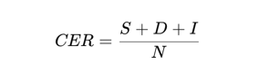

Where:  
- S is the total number of substitutions (incorrect characters)   
- D is the total number of deletions (missing characters)  
- I is the total number of insertions (extra characters)  
- N is the total number of characters in the reference text

CER is typically expressed as a percentage, with lower values indicating better performance. For example, a CER of 5% means that 5% of the characters in the system output are incorrect compared to the reference text.

### WER Calculation

Word Error Rate (WER) is another standard metric used to evaluate the performance of speech recognition systems, as well as in other domains like natural language processing where the correct transcription of words is crucial. Similar to CER, WER is based on edit distance, but operates at the word level rather than the character level.

WER is calculated as the sum of substitutions (S), insertions (I), and deletions (D) required to change the hypothesis ( the recognized word sequence) into the reference (the correct word sequence), divided by the number of words in the reference:

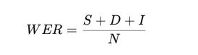

Where:  
- S is the total number of substitutions (incorrect words)  
- D is the total number of deletions (missing words)  
- I is the total number of insertions (extra words)  
- N is the total number of words in the reference text

WER is also expressed as a percentage, with lower values indicating better performance.

### CTCLoss Calculation

Connectionist Temporal Classification (CTC) Loss is a loss function used primarily for sequence prediction tasks without a pre-defined alignment between the input and the output. This is especially useful in tasks like speech recognition, where the length of the speech input does not directly correspond to the length of the transcribed text output.

CTC is designed to align sequences of predictions to the target text by introducing a special ‘blank’ symbol that the algorithm can use to output when there is no confident prediction for a character at a given time step. This allows the algorithm to map sequences of varying lengths to each other.

The CTC loss function computes the probability of the target sequence given the input sequence and then takes the negative log of this probability as the loss value. It sums over all possible alignments of the input to the target, considering the insertions of blanks and the possibility of collapsing repeated characters in the target.

The calculation of CTC loss involves dynamic programming and can be quite complex to explain in detail here, but a simplified explanation is as follows:

Compute the probabilities of each character at each time step in the input sequence (including the ‘blank’). Sum the probabilities of all valid paths through the time steps that correspond to the correct labeling (taking into account the collapsing of repeated characters and the placement of blanks). The loss is then the negative log probability of the correct sequence, which can be computed efficiently using the forward-backward algorithm. Mathematically, for a single instance, CTC loss can be described as:

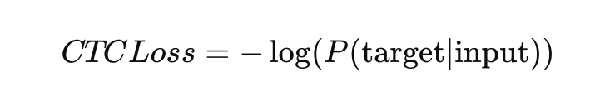

Where P(target∣input) is the probability of the target sequence given the input sequence. This is the sum of the probabilities of all possible paths that correctly map the inputs to the target sequence.

CTC is used in training time to provide a differentiable loss value that the optimizer can minimize, and during inference, it is used with a decoding step (such as greedy decoding or beam search) to output the final predicted sequence.

CTC Alignment

Connectionist Temporal Classification (CTC) is an algorithm used to train deep learning models, particularly Recurrent Neural Networks (RNNs), for sequence prediction problems where the alignment between the inputs and the target outputs is not known beforehand. It is extensively used in tasks like speech and handwriting recognition, where the length of the audio or written input does not directly correspond to the length of the output text.

The CTC algorithm works through the following process:

1. Input Processing: An RNN processes the input sequence (e.g., audio frames or video frames) and outputs a sequence of probability distributions over the possible output tokens, which include a special ‘blank’ token.
2. Alignment and Probability Distribution: The output sequence from the RNN consists of a probability distribution for each time step, providing probabilities for all possible output tokens, including the blank token.
3. Possible Alignments Generation: CTC generates all possible alignments of the output tokens that can be mapped to the target sequence, including the use of the blank token. This accounts for situations where certain input features may not clearly correspond to any output token or may correspond to the same token repeatedly.
4. Merge Repeated Tokens and Remove Blank Tokens: CTC merges consecutive repeated tokens and removes the blank tokens from the alignment to produce the final output sequence. For example, the sequence “a–aa-abb” would collapse to “aab”. Loss Computation: The CTC loss function calculates the total probability of the correct target sequence by summing the probabilities of all possible valid alignments that map to the target sequence. The loss is then defined as the negative log-likelihood of these probabilities.
5. Optimization: During training, the network’s parameters are optimized to minimize the CTC loss. This encourages the network to learn alignments that maximize the probability of the correct target sequence.
6. Decoding: During inference, a decoding step is used to convert the output probability distributions into a final sequence. The most common decoding strategies are greedy decoding, which selects the most likely token at each time step, and beam search decoding, which keeps track of multiple possible sequences to find a better approximation of the most likely output sequence.

CTC is particularly powerful because it enables the model to be trained end-to-end without any pre-segmented training data, and it allows for variable-length input sequences to be mapped to variable-length output sequences. This is achieved without any explicit alignment between the input and output sequences, which makes CTC applicable to a wide range of sequence prediction tasks.

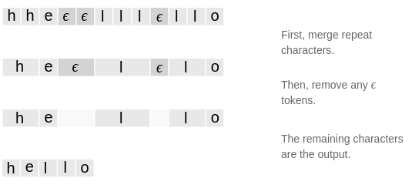

CTC example for Alignment

### Beam Search and Greedy Search

Beam search is a heuristic search algorithm that explores a graph by expanding the most promising node in a limited set. It’s commonly used in sequence prediction problems, especially where the space of possible sequences is very large, like machine translation, speech recognition, and text summarization. Greedy search, on the other hand, is a simple search algorithm that makes the best choice at each step with the hope of finding the optimal solution. It’s computationally efficient but may not always lead to the best overall solution.

Beam search is a balance between the greedy search, which always selects the single best node at each step, and breadth-first search, which considers all possible nodes. It is a useful algorithm when the goal is to find a reasonably good solution in a large or infinite search space where exhaustive search is not feasible.

In the context of lip-reading, beam search can be used to decode the output of the lip-reading model, which generates a sequence of characters or words. By exploring multiple possible paths through the sequence, beam search can find the most likely transcription of the input video data. This is particularly useful when the lip-reading model outputs probabilities for each character or word, and the final transcription needs to be determined based on these probabilities.

## Results

The table below encapsulates the comparative analysis of two models trained on the Grid Corpus datasets, differentiated by input resolution. The first model processed inputs at a low resolution of 35x70 pixels, while the second model operated at a high-resolution setting of 70x140 pixels. Both models underwent training for 100 epochs, sharing a consistent batch size of 4 and a learning rate set to 0.0001.

The results highlight a stark contrast in performance, with the high-resolution model exhibiting a Character Error Rate (CER) of 0.0008 and a Word Error Rate (WER) of 0.0033. These figures significantly outperform the low-resolution counterpart, which registered a CER of 0.3034 and a WER of 0.3015. The comparative metrics unequivocally demonstrate the superiority of the high-resolution model, underscoring the critical role of input resolution in the effectiveness of lip-reading models. The high-resolution model’s performance emphasizes its enhanced capacity to accurately interpret and predict based on the datasets, leading to substantial improvements in both CER and WER.

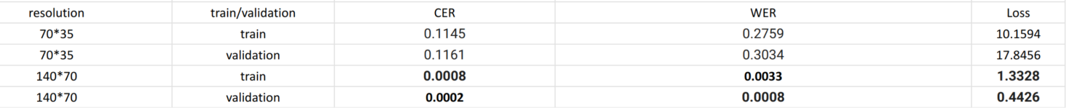

Comparative Analysis of Lip-Reading Models

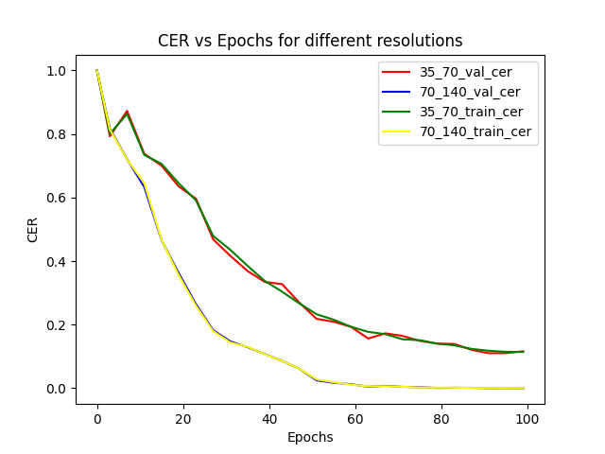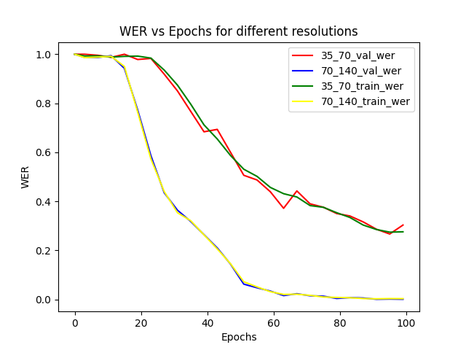

CER and WER for different models

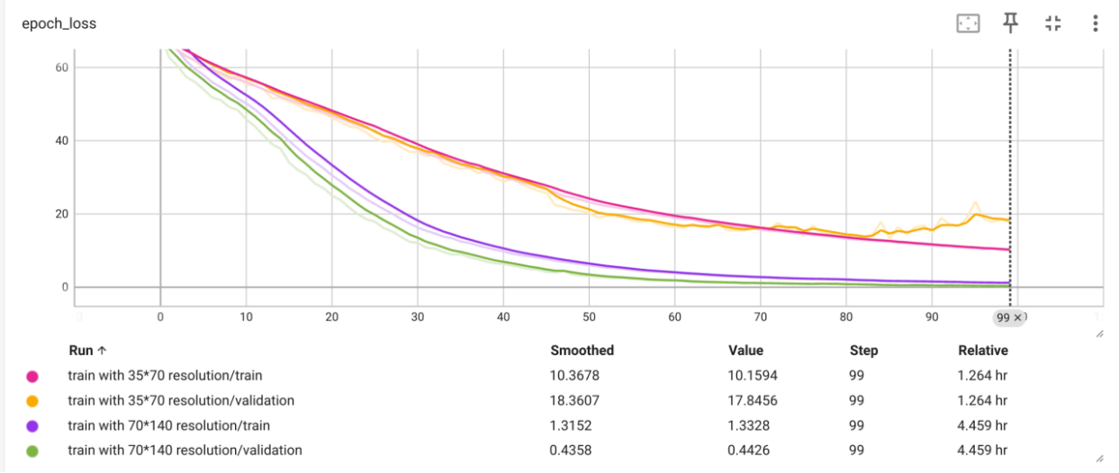

CTC Loss for different models

The graphical representations underscore the comparative analysis of two distinct resolution models trained on the same dataset, spotlighting a conspicuous divergence in performance. The graphs for both Character Error Rate (CER) and Word Error Rate (WER) conspicuously delineate the substantial discrepancy in proficiency, with the high-resolution model attaining an accuracy that verges on perfection, a stark contrast to its low-resolution counterpart.

The CTC loss graph serves as a further testament to the dominance of the high-resolution model, illustrating its adeptness at mitigating loss and honing training efficacy. Despite these advantages, the high-resolution model demands greater computational expenditure and memory usage, which could pose constraints on its scalability and practical application within real-world settings.

Conversely, the low-resolution model, despite trailing in accuracy, presents a more computationally frugal option, potentially aligning better with the confines of resource-restricted environments. The trade-off between precision and computational demand is encapsulated by the differential in training duration—4.319 hours for the higher resolution, against a substantially shorter span of 1.212 hours for the lower resolution. This dichotomy is crucial when considering the deployment context, be it for on-device applications where efficiency is paramount, or cloud-based solutions where resource availability may be less of a concern.

# Conclusions

## Introduction

This chapter draws together the key findings from the research, providing a conclusive insight into the comparative analysis of low-resolution and high-resolution lip-reading models trained on the Grid Corpus dataset. The chapter will distill the essence of the data, reflect on the implications of the results, and propose recommendations for future work in the domain.

## Reflection

The study’s core revelations are quite profound. The high-resolution model demonstrated superior accuracy, with lower Character Error Rate (CER) and Word Error Rate (WER), substantiating the hypothesis that higher input resolutions significantly enhance model performance in lip-reading tasks. This performance leap is attributed to the model’s ability to capture finer details and nuances in lip movement, which are pivotal for accurate lip-reading.

However, the results also brought to light the trade-offs between accuracy and computational efficiency. While the high-resolution model excelled in precision, it also required more than thrice the computational time compared to the low-resolution model. This finding is particularly relevant in the context of real-world applications where resources and processing time are often limited.

## Recommendations

Based on the insights gleaned from this research, the following recommendations are proposed:

Model Optimization: For environments where computational resources are constrained, it is recommended to focus on optimizing high-resolution models to reduce complexity without a significant compromise on accuracy. Hybrid Approaches: Investigate hybrid models that can dynamically adjust resolution based on the complexity of the input data and available computational resources, potentially combining the strengths of both resolution models. Hardware Considerations: Develop specialized hardware accelerators that can more efficiently handle high-resolution data, reducing the computational load on general-purpose processors.

Extended Datasets: To generalize the findings, replicate the study across a wider range of datasets and in more diverse conditions to validate the model’s robustness and performance consistency.

Real-World Testing: Pilot the high-resolution model in real-world scenarios to evaluate its performance in practical settings, gather user feedback, and refine the model accordingly.

Accessibility: Consider the implications of these findings for assistive technologies, and how such lip-reading models can be developed to better serve individuals with hearing impairments. In conclusion, while the findings favor the high-resolution model for its accuracy, the considerations around deployment and resource management are non-trivial. As the field of lip-reading technology advances, it is imperative to balance computational demands with the quest for precision, ensuring that these innovations are both effective and accessible for all intended applications.

## Concerns and feature work

Despite the remarkable accuracy observed in the Word Error Rate (WER) and Character Error Rate (CER) metrics, there are pertinent concerns that must be addressed. A paramount concern is the potential for over-fitting. Given the high performance on the Grid Corpus datasets, one must critically assess whether the model has simply memorized the datasets patterns rather than learned to generalize from them. This is a significant risk, especially considering the constrained vocabulary of the datasets, which may not reflect the complex and variable nature of real-world scenarios.

Furthermore, the current methodology employs a character-spelling approach to prediction. While technically effective, this method diverges from natural human linguistic processes, which lean more heavily on phonemes—the distinct units of sound that distinguish one word from another in language—for word construction and pronunciation. This deviation suggests a gap between the model’s operational logic and human speech patterns, which could impede the model’s applicability in more naturalistic settings.

Lastly, the integration of a language model stands out as a vital component for future enhancement. Such a model would contextualize the predictions, refining accuracy by incorporating syntactic and semantic understandings of language. This addition could vastly improve the model’s ability to predict sequences that are not just phonetically accurate but also linguistically coherent, thereby moving towards a more human-like performance in lip-reading tasks. Addressing these concerns is essential for advancing the model beyond controlled conditions and into the multifaceted realm of everyday communication.

##### References

1. J. K. Chorowski, D. Bahdanau, D. Serdyuk, K. Cho, and Y. Bengio. Attention-based models for speech recognition. In Advances in Neural Information Processing Systems, pages 577–585, 2015.
2. J. S. Chung et al., "Lip Reading in the Wild," ACM Transactions on Graphics, vol. 36, no. 4, Article 31, July 2017.
3. C. C. Cook et al., "GRID Corpus: A Multimodal Dataset for Research in Automatic Lip-Reading," Proc. of the International Conference on Auditory-Visual Speech Processing, 2006.
4. Son Chung, Joon, et al. "Lip reading sentences in the wild." Proceedings of the IEEE conference on computer vision and pattern recognition. 2017.
5. A. Afouras et al., "Deep Audio-Visual Speech Recognition," IEEE Transactions on Pattern Analysis and Machine Intelligence, 2018.
6. N. Harte and E. Gillen, "TCD-TIMIT: An Audio-Visual Corpus of Continuous Speech," IEEE Transactions on Multimedia, vol. 17, no. 5, May 2015.
7. L. Matthews et al., "Extracting Visual Features for Lipreading," IEEE Transactions on Pattern Analysis and Machine Intelligence, vol. 24, no. 2, Feb 2002.
8. Y. Ephrat et al., "Looking to Listen at the Cocktail Party: A Speaker-Independent Audio-Visual Model for Speech Separation," ACM Transactions on Graphics, vol. 37, no. 4, Article 112, August 2018.
9. A. Ben-Hamadou et al., "MIRACL-VC1: A Multi-Speaker Visual Corpus for Lip-Based Speaker Verification," IEEE International Conference on Acoustics, Speech and Signal Processing, 2014.
10. P. Ma, S. Petridis, M. Pantic, "End-to-End Audio-Visual Speech Recognition with Conformers," Department of Computing, Imperial College London, 2021.
11. Y. Assael, B. Shillingford, S. Whiteson, N. de Freitas, "LipNet: End-to-End Sentence-level Lipreading," 2016.
12. Shillingford, Brendan, et al. "Large-scale visual speech recognition." arXiv preprint arXiv:1807.05162 (2018).
13. E. Battenberg et al., "Exploring Neural Transducers for End-to-End Speech Recognition," Google Research, 2017.
14. P. Ma, Y. Wang, J. Shen, S. Petridis, and M. Pantic, ‘‘Lip-reading with densely connected temporal convolutional networks,’’ in Proc. IEEE Winter Conf. Appl. Comput. Vis. (WACV), Jan. 2021, pp. 2857–2866.
15. M. Luo, S. Yang, S. Shan, and X. Chen, ‘‘Pseudo-convolutional policy gradient for sequence-to-sequence lip-reading,’’ in Proc. 15th IEEE Int. Conf. Autom. Face Gesture Recognit. (FG), Nov. 2020, pp. 273–280.
16. S. Fenghour, D. Chen, K. Guo, and P. Xiao, ‘‘Lip reading sentences using deep learning with only visual cues,’’ IEEE Access, vol. 8, pp. 215516–215530, 2020.
17. A. Fernandez-Lopez and F. M. Sukno, ‘‘Survey on automatic lip-reading in the era of deep learning,’’ Image Vis. Comput., vol. 78, pp. 53–72, Oct. 2018.
18. Y. Lu and H. Li, ‘‘Automatic lip-reading system based on deep convolutional neural network and attention-based long short-term memory,’’ Appl. Sci., vol. 9, no. 8, p. 1599, Apr. 2019.
19. S. Petridis et al., "Audio-Visual Speech Recognition with a Hybrid CTC/Attention Architecture," 2018.
20. Z. Wu et al., "Lip Reading Sentences in the Wild," Machine Learning, 2016.[x]
21. H. Kim, J. H. Hong, B. Roh, "Lip-to-Speech Synthesis in the Wild with Multi-Task Learning," KAIST, 2020.
22. S. Petridis, Y. Wang, Z. Li, M. Pantic, "End-to-End Audiovisual Fusion with LSTMs," IEEE Transactions on Affective Computing, 2019.
23. X. Yang et al., "LRW-1000: A Naturally-Distributed Large-Scale Benchmark for Lip Reading in the Wild," Pattern Recognition Letters, 2019.
24. A. Graves, S. Fernández, F. Gomez, and J. Schmidhuber, “Connectionist temporal classification: labelling unsegmented sequence data with recurrent neural networks,” in Proceedings of the 23rd international conference on Machine learning. ACM, 2006, pp. 369–376.
25. S. Yang, Y. Zhang, D. Feng, M. Yang, C. Wang, J. Xiao, K. Long, S. Shan, and X. Chen, ‘‘LRW-1000: A naturally-distributed large-scale benchmark for lip reading in the wild,’’ in Proc. 14th IEEE Int. Conf. Autom. Face Gesture Recognit. (FG), May 2019, pp. 1–8
26. T. Afouras, J. S. Chung, and A. Zisserman, ‘‘LRS3-TED: A large-scale dataset for visual speech recognition,’’ 2018, arXiv:1809.00496. [Online]. Available: <https://arxiv.org/abs/1809.00496>
27. A. Vaswani, N. Shazeer, N. Parmar, J. Uszkoreit, L. Jones, A. N. Gomez, L. Kaiser, and I. Polosukhin, ‘‘Attention is all you need,’’ in Proc. NIPS, 2017, pp. 5998–6008.
28. Chiu, C.C., et al.: State-of-the-Art speech recognition with sequence-to-sequence models. In: ICASSP, IEEE International Conference on Acoustics, Speech and Signal Processing - Proceedings, pp. 4774–4778 (2018).
29. Noda, K., et al.: Lipreading using convolutional neural network. In: Proceedings of the Annual Conference of the International Speech Communication Association, pp. 1149–1153. INTERSPEECH (2014). (September). <https://doi.org/10.21437/interspeech.2014-293>
30. Bickford, J. A. & Fraychineaud, K. (2008). Mouth morphemes in ASL: A closer look. Sign Languages: Spinning and unravelling the past, present and future, Theoretical issues in sign language research (TISLR9) conference. Florianopolis, Brazil.
31. Lu, Y.; Li, H. Automatic Lip-Reading System Based on Deep Convolutional Neural Network and Attention-Based Long Short-Term Memory. Appl. Sci. 2019, 9, 1599.
32. S. Shilaskar and H. Iramani, "CTC-CNN-Bidirectional LSTM based Lip Reading System," 2024 International Conference on Emerging Smart Computing and Informatics (ESCI), Pune, India, 2024, pp. 1-6, doi: 10.1109/ESCI59607.2024.10497275.
33. Zhao, Y., Xu, R., & Song, M. (2020). A cascade sequence-to-sequence model for Chinese Mandarin lip reading. In Proceedings of the 1st ACM International Conference on Multimedia in Asia (Article No. 32, pp. 1-6). ACM. <https://doi.org/10.1145/3338533.3366579>
34. X. Ai and B. Fang, "Cross-Modal Language Modeling in Multi-Motion-Informed Context for Lip Reading," in IEEE/ACM Transactions on Audio, Speech, and Language Processing, vol. 31, pp. 2220-2232, 2023, doi: 10.1109/TASLP.2023.3282109.
35. Oghbaie, Marzieh, et al. "Advances and challenges in deep lip reading." arXiv preprint arXiv:2110.07879 (2021).
36. Ephrat, A.; Mosseri, I.; Lang, O.; Dekel, T.; Wilson, K.; Hassidim, A.; Freeman, W.T.; Rubinstein, M. Looking to listen at the cocktail party: A speaker-independent audio-visual model for speech separation. arXiv 2018, arXiv:1804.03619.
37. Hong, Joanna, et al. "Watch or listen: Robust audio-visual speech recognition with visual corruption modeling and reliability scoring." Proceedings of the IEEE/CVF Conference on Computer Vision and Pattern Recognition. 2023.

##### Glossary

**Activation Function**: A function in a neural network that introduces non-linearity, allowing the network to learn complex patterns.

**Backpropagation**: An algorithm used in training neural networks, where the error is propagated back through the network to update the weights.

**Batch Size**: The number of training samples used in one iteration of model training.

**Beam Search**: A search algorithm that expands the most promising nodes in a limited set and is often used in sequence prediction tasks.

**Character Error Rate (CER)**: A performance metric in lip-reading that measures the character-level discrepancies between the predicted and actual text.

**Convolutional Neural Network (CNN)**: A type of neural network that uses convolution operations to process data in a grid-like topology, such as images.

**Conv3D**: A type of convolutional neural network that operates on 3D data, such as video sequences. CTC Loss (Connectionist Temporal Classification Loss): A type of loss function used for training sequence prediction models without a pre-defined alignment between inputs and outputs.

**Dataset:** A collection of data used for training or evaluating a neural network.

**Dense Layer:** A fully connected neural network layer where each input node is connected to each output node.

**Epoch**: One complete pass of the training dataset through the neural network.

Feature Extraction: The process of transforming raw data into a set of features that can be used for training a model.

**Grid Corpus Dataset**: A standard dataset used in visual speech recognition, consisting of controlled, head-and-shoulders video recordings of subjects speaking.

**Learning Rate:** A hyperparameter that controls the amount by which the weights of the neural network are updated during training.

**LSTM (Long Short-Term Memory)**: A type of recurrent neural network (RNN) architecture used to learn dependencies in sequence prediction problems.

**Normalization**: The process of adjusting and scaling data to a standard range.

**Optical Character Recognition (OCR):** The conversion of different types of documents, such as scanned paper documents, PDFs, or images captured by a digital camera, into editable and searchable data.

**Overfitting**: A modeling error in neural networks where the model learns the detail and noise in the training data to the extent that it negatively impacts the performance on new data.

**Phoneme**: The smallest unit of sound in a language that can distinguish one word from another.

**Recurrent Neural Network (RNN)**: A type of neural network where connections between nodes form a directed graph along a temporal sequence, allowing it to exhibit temporal dynamic behavior.

**TensorFlow**: An open-source software library for dataflow and differentiable programming across a range of tasks, primarily used for training and inference of deep neural networks.

**Transfer Learning**: A machine learning method where a model developed for a task is reused as the starting point for a model on a second task.

**WER (Word Error Rate)**: A common metric for measuring the performance of an automatic speech recognition system, indicating the percentage of words incorrectly predicted.

**Streamlit**: A Python library that enables the creation of web apps for machine learning and data science with minimal coding effort.

**Softmax Activation Function**: A function that converts the output of a neural network into a probability distribution over multiple classes.

**Sequence2Sequence (Seq2Seq)**: A neural network architecture used for sequence prediction tasks, such as machine translation or speech recognition.

##### List of Abbreviations

| **Abbreviation** | **Full Form** |
| --- | --- |
| **ANN** | **Artificial Neural Network** |
| **ASR** | **Automatic Speech Recognition** |
| **BiLSTM** | **Bidirectional Long Short-Term Memory** |
| **CER** | **Character Error Rate** |
| **CNN** | **Convolutional Neural Network** |
| **CTC** | **Connectionist Temporal Classification** |
| **DNN** | **Deep Neural Network** |
| **FC** | **Fully Connected (layer)** |
| **GRU** | **Gated Recurrent Unit** |
| **LSTM** | **Long Short-Term Memory** |
| **ML** | **Machine Learning** |
| **MLP** | **Multilayer Perceptron** |
| **NLP** | **Natural Language Processing** |
| **OCR** | **Optical Character Recognition** |
| **ReLU** | **Rectified Linear Unit** |
| **RNN** | **Recurrent Neural Network** |
| **SGD** | **Stochastic Gradient Descent** |
| **WER** | **Word Error Rate** |
| **GPU** | **Graphics Processing Unit** |
| **TPU** | **Tensor Processing Unit** |
| **CV** | **Computer Vision** |
| **API** | **Application Programming Interface** |
| **MSE** | **Mean Squared Error** |
| **RMSE** | **Root Mean Squared Error** |
| **MAE** | **Mean Absolute Error** |
| **IoU** | **Intersection over Union** |
| **FPS** | **Frames Per Second / First Person Shooter** |
| **RGB** | **Red, Green, Blue (color model)** |
| **HSV** | **Hue, Saturation, Value (color model)** |
| **HMM** | **Hidden Markov Model** |
| **GMM** | **Gaussian Mixture Model** |

###### Appendix

The Online Platform for Lip-Reading

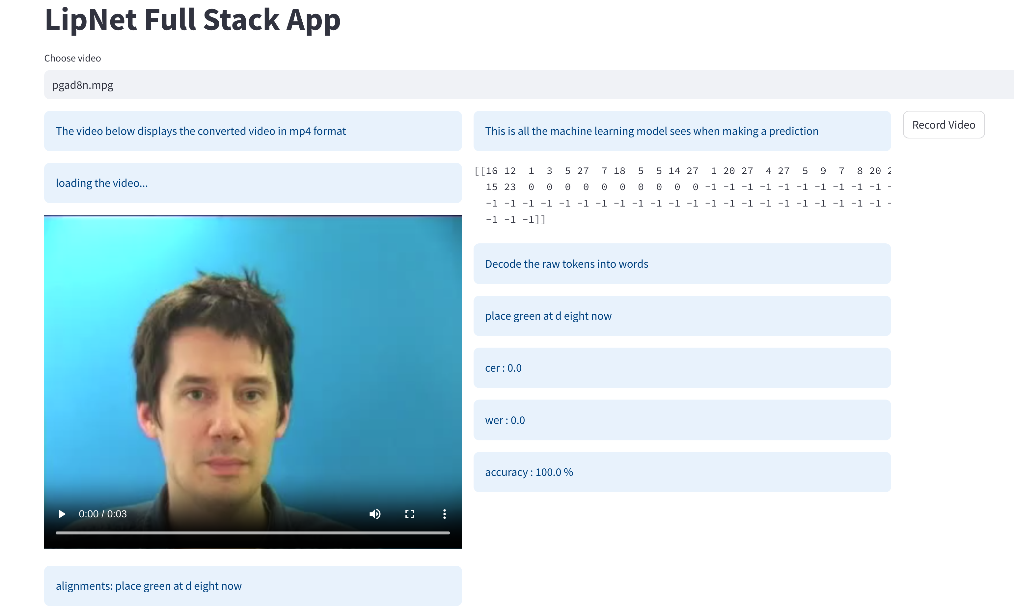

The Online Platform for Lip-Reading

In the online platform, users can choose the video file they want to test the lip-reading model on. The platform

separates the layout into two sections: the left side displays the video file information (load the video, display the

alignments) and the right side shows the predicted text and the Word Error Rate (WER), Character Error Rate (CER) as

well as the accuracy of the model.